Phase 6
Project Documentation

Project Documentation Format
(Adapted from the Full-Stack Development documentation format for a zero-code, native ServiceNow platform solution.)

1. Introduction
Project Title: Virtual Agent–Driven SLA Breach Awareness & Justification System
Team Members: [List team members and their roles]

2. Project Overview
Purpose: To proactively detect SLA breach risk, enforce breach accountability through mandatory justification, guide assignees via a conversational Virtual Agent, and give leadership real-time visibility into SLA performance — all without custom code.
Features: Automated SLA risk detection, Virtual Agent guided acknowledgement, mandatory breach justification (UI Policy), role-based access control (ACL), an executive Performance Analytics dashboard, configurable per-SLA thresholds, and manager escalation for unacknowledged risk.

3. Architecture
Platform (in place of a traditional frontend/backend/database split, this solution runs entirely natively within ServiceNow):
- "Frontend" equivalent: ServiceNow Service Portal / Now Experience UI and the Virtual Agent chat widget, through which assignees view alerts and interact with governance prompts.
- "Backend" equivalent: Flow Designer flows/subflows (SLA Risk Monitor), UI Policies, and Business Rules implementing all process logic declaratively.
- "Database" equivalent: Native ServiceNow platform tables — Task/Incident, SLA definitions, and the system audit table (sys_audit) — storing all governance and justification data.
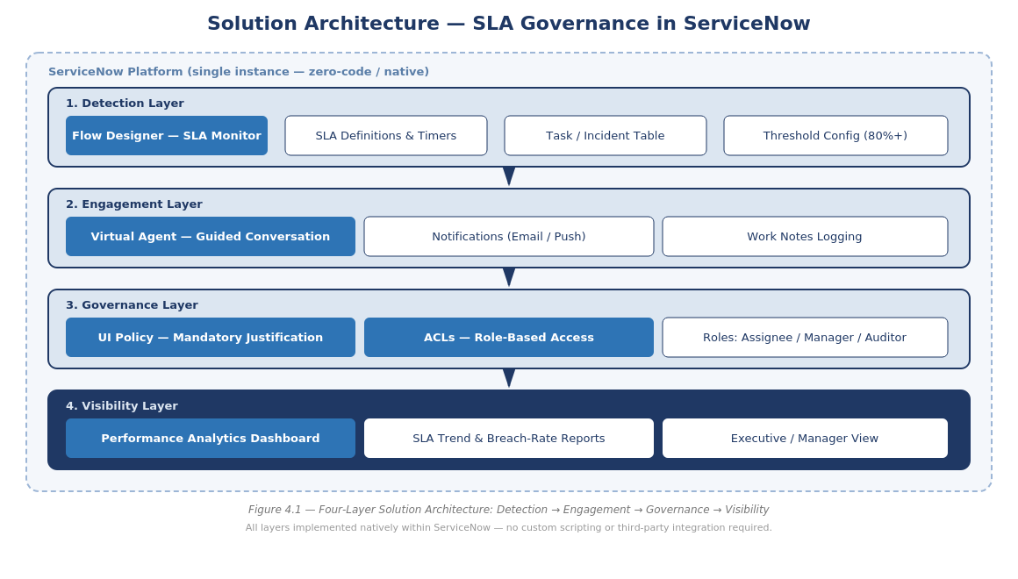
Figure 6.1 — Platform Architecture

4. Setup Instructions
Prerequisites: A ServiceNow instance (sub-production/developer instance recommended) with admin access, Flow Designer, Virtual Agent, and Performance Analytics plugins active.
Installation: Import the exported Update Set containing the SLA Risk Monitor flow, UI Policies, ACLs, and Virtual Agent topic; commit to the target instance; configure SLA threshold values and role assignments for your environment.
- Step 1: Retrieve Update Set XML from the source instance or repository.
- Step 2: Navigate to System Update Sets > Retrieved Update Sets and import the XML.
- Step 3: Preview and commit the Update Set, resolving any collisions with existing configuration.
- Step 4: Configure SLA threshold values under the SLA Risk Monitor flow's input variables.
- Step 5: Assign the Assignee, Manager, and Auditor roles to the appropriate user groups.

5. Folder / Configuration Structure
- Flow Designer: SLA Risk Monitor flow and supporting subflows
- UI Policies: Breach justification enforcement rules on the Incident/Task form
- Access Control: ACL rules restricting SLA-field edits to the assignee role
- Virtual Agent: Guided-conversation topic for SLA-risk acknowledgement
- Reports/Dashboards: Performance Analytics widgets for the executive dashboard

6. Running the Application
No local build or server start is required — the solution runs live within the ServiceNow instance once the Update Set is committed and SLA definitions/thresholds are configured. Agents interact with it directly through their existing Agent Workspace and notification channels; no separate login or application is needed.

7. API / Integration Documentation
Document any Flow Designer REST/Integration steps or external notification endpoints used, if applicable. Not applicable if the solution is fully self-contained within ServiceNow.

8. Authentication & Authorization
Authentication is handled by native ServiceNow platform login (SSO/LDAP as configured on the instance). Authorization is enforced through role-based Access Control Lists (ACLs): only the assignee role may edit SLA-critical fields, while manager and auditor roles retain read-only visibility. Justification entries become non-editable once submitted, preserving audit integrity.

9. User Interface
Insert screenshots or GIFs of: the SLA-risk alert, the Virtual Agent conversation, the UI Policy-enforced justification field, and the executive dashboard.

10. Testing
Testing strategy and tools are documented in full under Phase 5 — Project Development Phase (Functional & Performance Testing / UAT), covering 10 functional test cases, 5 performance metrics, and bug tracking with sign-off procedures.

11. Screenshots or Demo
Insert screenshots or a link to a demo video showcasing the end-to-end SLA governance flow.

12. Known Issues
Document any known bugs, limitations, or configuration caveats (e.g., threshold tuning needed to avoid alert fatigue, or NLU intent conflicts in the Virtual Agent topic).

13. Future Enhancements
- Extend SLA governance beyond Incident/Task tables to HRSD, CSM, and custom applications.
- Introduce predictive SLA-breach risk scoring using ServiceNow Predictive Intelligence.
- Add manager escalation paths and automated re-assignment for high-risk SLAs.
- Expand the Virtual Agent to support proactive coaching based on historical breach patterns.
- Package the framework as a scoped application for distribution via the ServiceNow Store or as an internal accelerator template.

